Parts List Tab received the most votes when I asked which apps I should update. Keep in mind, this is a straight port from the Vault 2011 version. I didn’t have time to add new features.
For those of you not familiar with the app, it creates a new file tab. When you select a file that has Item information, the tab displays the parts list from the Item BOM.
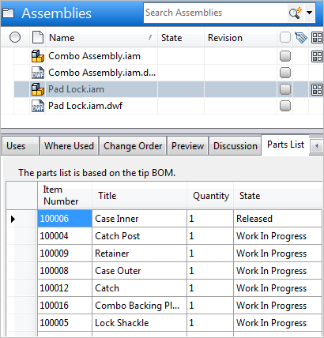
Thanks again to Jim McMullen for writing the app.
Requirements:
Vault Professional 2013
Click here to download application
Click here to download source
As with all the sample apps on this site, the legal disclaimer applies.

